1.4.4J

|  |  |
| --- | --- |
| **תרמילון הוראות בתכנות** | **הוראות במלל** |
| y = 10; |  |
| x = x + y; |  |
| y = input.nextInt(); |  |
| x = input.nextInt(); |  |
| System.out.println(x + "," + y); |  |
| System.out.println(x + "," + y); |  |
| int x, y; |  |

1.4.5J (need to update the ;)

|  |  |
| --- | --- |
| **תרמילון הוראות בתכנות** | **הוראות במלל** |
| double num; |  |
| a = "SPEEDO"; |  |
| System.out.println(a+b+”=”+c); |  |
| int c; |  |
| b = "METER"; |  |
| num = 20.8; |  |
| c = (int)num; |  |

1.6.4j.png 939 X 410

|  |  |
| --- | --- |
| **פקודת הדפסה** | **הפלט שיופיע** |
| System.out.println("{0} in {1}", name, place); |  |
| System.out.println("{1} in {0}", name, place); |  |
| System.out.println("Price per ticket {0} NIS, number of tickets {1}", price, tickets); |  |
| System.out.println("Total price: {0} NIS", tickets * price); |  |

פרק 2

עברתי לגוגל DOCS מפני שהוא יודע לשמור את הצבעים מתוך העיצוב של קמפוס (בטקסט ללא צורך בהעתקת תמונה).

**5.4 Q6**

public static void D()

{

for (int x = 1; x <= 2; x++)

{

for (int y = 1; y <= 4; y++)

{

Console.WriteLine("*");

}

}

Console.Write("**");

}

public static void C()

{

for (int x = 1; x <= 2; x++)

{

for (int y = 1; y <= 4; y++)

{

Console.Write("*");

}

}

Console.WriteLine();

Console.WriteLine("**");

}

public static void A()

{

for (int x = 1; x <= 2; x++)

{

for (int y = 1; y <= 4; y++)

{

Console.Write("*");

}

}

Console.WriteLine("**");

}

public static void B()

{

for (int x = 1; x <= 2; x++)

{

for (int y = 1; y <= 4; y++)

{

Console.Write("*");

}

Console.WriteLine("**");

}

Console.WriteLine("**");

}

7.0:

public static void RecognizeA()

{

int i = 1;

for (int i = 0; i < 10; i++)

{

Console.WriteLine(i);

}

}

public static void RecognizeB()

{

for (int x = 6; x > 0; x--)

{

int x = 7;

Console.WriteLine(x);

}

}

public static void RecognizeC()

{

int a;

for (a = 0; a < 10; a += 2)

{

Console.WriteLine(a);

}

Console.WriteLine("last a = " + a);

}

public static void RecognizeD()

{

for (int b = 1; b < 10; b += 3)

{

Console.WriteLine(b);

}

Console.WriteLine("last a = " + b);

}

|  |  |
| --- | --- |
| **קטע קוד** | **תרמילון הודעות פלט** |
| System.out.println(w.substring(8)); |  |
| System.out.println(w.substring(4, 7)); |  |
| System.out.println(w.substring(0)); |  |
| System.out.println(w.substring(14)); |  |
| System.out.println(w.substring(3, 15)); |  |
| System.out.println(w.substring(0, 3)); |  |

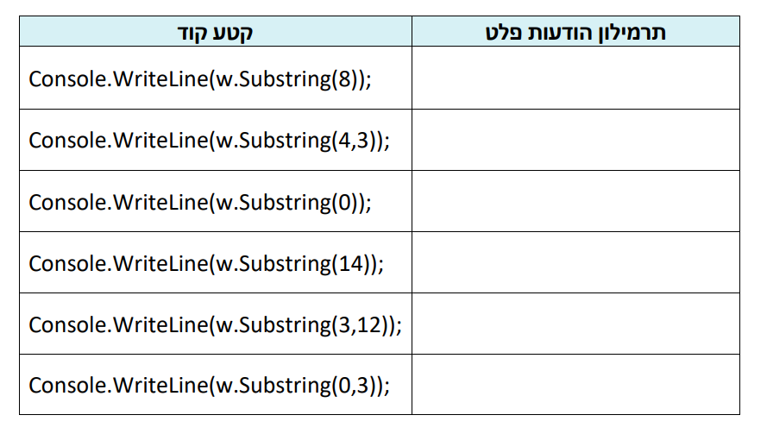

|  |  |
| --- | --- |
| **הוראות** | **הפלט** |
| if (a1.equals(a5)) System.out.println(1); else System.out.println(11); |  |
| if (a1.equals(a2)) System.out.println(2); else System.out.println(22); |  |
| if (a2.equals(a3)) System.out.println(3); else System.out.println(33); |  |
| if (a4.equals(a1)) System.out.println(4); else System.out.println(44); |  |
| if (a1 == a5) System.out.println(5); else System.out.println(55); |  |
| if (a1 == a2) System.out.println(6); else System.out.println(66); |  |
| if (a2 == a3) System.out.println(7); else System.out.println(77); |  |
| if (a4 == a1) System.out.println(8); else System.out.println(88); |  |

